

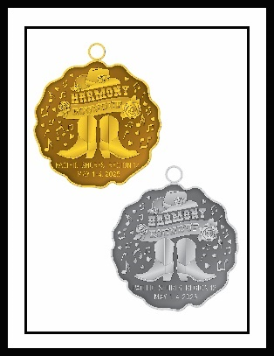

REGION 12 CONTEST 2025

CHARM ORDER FORM

**$25** EACH CHARM – Silver or Gold tone (ONLY)

**ORDERS DUE BY March 10th 2025**

CHORUS NAME: _____________________________________________

Please send order form and checks made out to Diablo Vista Chorus (1 check per chorus) to

Louise Johnson, 421 Siesta Drive, Aptos, CA 95003

** The region must receive a minimum of 100 charm orders total to be able to place this order

|  |  |  |  |
| --- | --- | --- | --- |
| MEMBER NAME: | Color | # OF CHARMS | $ AMOUNT |
|  |  |  |  |
|  |  |  |  |
|  |  |  |  |
|  |  |  |  |
|  |  |  |  |
|  |  |  |  |
|  |  |  |  |
|  |  |  |  |
|  |  |  |  |
|  |  |  |  |
|  |  |  |  |
|  |  |  |  |
|  |  |  |  |
|  |  |  |  |
|  |  |  |  |
|  |  |  |  |

.