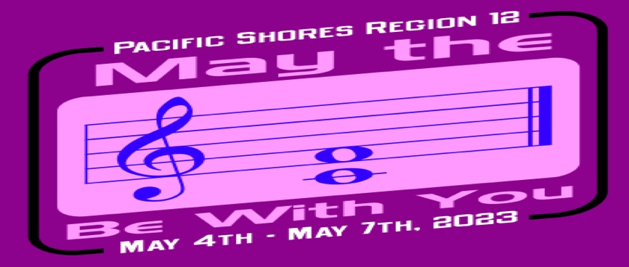
REGION 12 CONTEST 2023
CHARM ORDER FORM
$20 EACH CHARM – BRONZE ONLY
ORDERS DUE BY FEB. 20th

CHORUS NAME: _____________________________________________

NAME: |  | # OF CHARMS | $ AMOUNT

Please send order form and checks made out to Pacific Shores Region 12 (1 check per chorus) to
Mary Heil – 1200 Ptarmigan Dr. #2 – Walnut Creek, CA 94595

** The region must receive a minimum of 100 charm orders total to be able to place this order.

